CHAPTER 13
SOUTHERN COMPANY
JIM GREENE

A robust leadership development and succession planning process that uses leadership performance standards and competencies to identify successors and high-potential individuals, and target development.
• Introduction
• Background
• Initial Improvements
• The Leadership Action Council
• Competency Model
• Leadership Assessment
• Succession Planning
• Identification of Potential Successors and High-Potential Individuals
• Assessment of the Talent
• Review of Individuals
• Leadership Database
• Development Activities
• Senior Leader Development Program
• Emerging Leader Program
• Evaluation and Lessons Learned
• Evaluation
• Lessons Learned

INTRODUCTION
Having a steady supply of leaders with the right skills in the right jobs is critical to the success of an organization. Facing the possibility that a number of long-tenured leaders across all levels would soon retire, Southern Company enhanced its succession planning and leadership development processes to ensure a full leadership pipeline to sustain business success. This chapter details these processes.

BACKGROUND
Southern Company is an electric utility serving 4.4 million customers in the southeastern United States. A leading U.S. producer of electricity, Southern Company owns electric utilities in four states and a growing competitive generation company, as well as fiber optics and wireless communications. Southern Company brands are known for excellent customer service, high reliability, and retail electric prices that are significantly below the national average. Southern Company has been listed as the top ranking U.S. electric service provider in customer satisfaction for nine consecutive years by the American Customer Satisfaction Index (ACSI). Southern Company employs approximately 26,000 people.
In 2003, America’s aging workforce began to receive a lot of attention and was viewed as a potential business challenge for Southern Company. A “grow your own” company, Southern Company historically hired at the entry level and relied on internal promotions rather than external hiring to fill leadership positions. In the late 1970s and 1980s, the company hired a large number of people. A low turnover rate resulted in the leadership group being very stable and growing progressively older. In 2003, the average age of executives was fifty-two. The average ages of middle managers and first-line managers were forty-nine and forty-seven, respectively. This age bubble posed a potential succession risk. Southern Company has developed a cadre of leaders who possessed deep business knowledge and fit the organization and culture. Projections showed that, as executives began to retire in greater numbers, their successors would leave soon after. The need to develop a new generation of leaders became the driver for re-looking at the succession and leadership development efforts to ensure a sustainable supply of quality leaders to meet business needs.
In early 2004, Southern Company’s CEO initiated an in-depth review of succession planning and leadership development. The goal of the study was to review current practices and determine the steps necessary to advance leadership development to the next level and ensure an adequate supply of leadership talent over the next ten years. The study began by interviewing a cross-section of executives and managers to gain an internal perspective of the strengths and gaps of the succession planning and leadership development systems. An external consultant was engaged to provide an objective third-party view and to provide best practice research.
The review noted several strengths. Senior leaders were engaged and devoted a significant amount of time to leadership development. During the interviews they talked about conducting mentoring groups and spending time getting to know key high-potential individuals in their company or business unit. Southern Company also had basic processes in place to identify and develop leaders. Succession planning was conducted annually, with its primary focus being on replacement planning. Assignments and development moves were used to provide individuals a wide range of experience. A number of decentralized leadership development activities were in place. These programs utilized a variety of activities, including mentoring, group mentoring, business acumen discussions, and education classes. A corporate action learning program for high-potential first-line leaders was conducted annually.
Several gaps were identified. During the interviews, leaders talked about knowing the high-potential talent in their organization very well. However, they did not know talent across Southern Company. Cross-system calibration of talent was difficult for several reasons. A standard set of information was not available for comparing individuals. Southern Company lacked a comprehensive model that identified the key leadership practices necessary to achieve business success. Across Southern Company there were a number of different definitions of leadership, and emphasis was placed on developing different skills and abilities. A person viewed as high-potential at one location may not have been viewed in a similar light at other locations. Managers also tended to promote individuals they knew and had working relationships with. The study also revealed that the assessment process lacked sufficient rigor to support critical talent decisions. Southern Company has had the luxury of multiple people viewing a person’s performance over a long period of time in different jobs and situations. This provided a good indication of people’s capabilities. However, because people were viewing leaders through different lenses, there were different opinions of people’s capabilities and potential to assume expanded roles. More objective measures to help predict potential were needed.
The succession planning process placed too much emphasis on replacement planning and not enough on developing critical talent pools. There was insufficient focus on high-potential talent five to ten years from the executive level. Leaders reported having difficulty targeting development to the most critical areas. A final gap noted information on succession plans and high-potential individuals was kept in a series of separate files located across Southern Company, making consolidated information difficult to obtain and use.

INITIAL IMPROVEMENTS
Following the review, Southern Company took steps to improve leadership development. The initial effort focused on building a common leadership framework across Southern Company, including a common definition and understanding of leadership. Southern Company adopted the leadership framework articulated by Ram Charan, Stephen Drotter, and James Noel in their book The Leadership Pipeline: How to Build the Leadership-Powered Company. Central to this framework is understanding that leadership begins with the work leaders perform. Managers go through key transitions in their careers when they move up the organizational ladder. The scope and complexity of work increases at each level, requiring new skills, time applications, and work values. Southern Company began building its leadership framework by identifying the major leadership transitions within the company and their associated requirements. Stephen Drotter was employed to help customize the framework for Southern Company. Selected executives and managers were interviewed, asking them to identify the major results they needed to produce in their jobs to be successful. This information was analyzed and resulted in six levels of leadership being identified within Southern Company:
• Individual contributor—leads self.
• First-line manager—leads a team of individual contributors. May have first-line supervisors reporting to him or her.
• Manager of managers—Leads a large department or organizational entity. Has first-line managers as direct reports.
• Functional manager—Leads a single function or organizational entity. Usually an officer.
• Multi-functional manager—Leads multiple functional areas.
• CEO/business unit manager/enterprise functional manager—Leads a company, major business unit, or a major function at the enterprise level.
For each level, the associated requirements (performance standards) were identified. Performance standards list the complete set of results expected of leaders at that level. For each level of leadership, the identified results were grouped under the following performance dimensions:
• Business (Operational, Technical, Financial)
• Management
• Leadership
• Relationships
• Community/External Involvement
• Customer
A sample set of performance standards for manager of managers is shown in Figure 13.1.
FIGURE 13.1.Manager of Manager Performance Standards
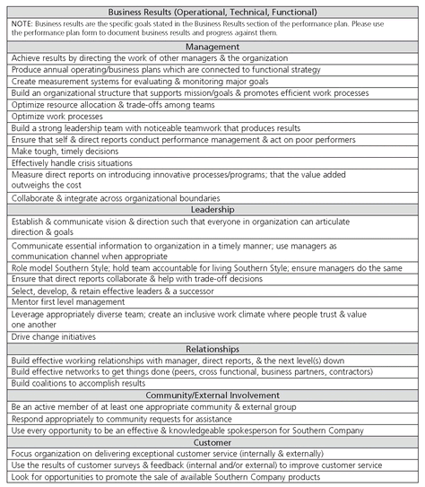
The identification of specific performance standards helped leaders understand the expectations for a particular level. They also helped build a common definition of leadership across Southern Company. Performance standards enabled more objective discussions of people and facilitated better development plans. Managers reported that their discussions of people became more objective because they were focused on a common set of expectations.
Performance standards were woven into succession and leadership development processes in several ways. A small group of human resource professionals were trained to conduct behavioral interviews to determine an individual’s performance relative to the performance standards. The results of these assessments were used in talent review sessions. Managers were trained to use the performance standards in their development discussions with leaders reporting to them. The performance standards were also used during succession planning to help identify high-potential individuals.
The use of performance standards in the succession planning process took hold in pockets of the organization. Overall, the implementation of performance standards was viewed as a human resource initiative rather than coming from line management. Some organizations used the standards in succession planning, while others used them as part of their development planning for leaders. They were not consistently applied in all parts of the organization. The accuracy of the behavioral interviews conducted by HR professionals was questioned by management. To fix these issues, Southern Company took several steps.

THE LEADERSHIP ACTION COUNCIL
In 2005, Southern Company’s CEO chartered a group of executives to serve as the steering committee for leadership development. This council was given the responsibility to develop guidelines and facilitate integration of leadership development programs and processes across Southern Company. The council is made up of senior line executives representing each operating company and business unit and the senior VP of HR. The formation of this council moved leadership development from being a human resource initiative to being line-driven. Human resources served in a partnership role with the council. Southern Company is a highly matrixed organization. Having a council that represented all of the parties was essential to gaining traction.
Building on the work done previously, the Leadership Action Council established project teams to research issues and make recommendations. These teams reviewed the areas of succession planning, leadership assessment, leadership development, and leadership education. Each project team was led by Leadership Action Council members, had line management participation, and utilized HR support. These teams reviewed best practices, gathered management input, determined gaps, and made recommendations. The Leadership Action Council made the following recommendations in 2006.
• Create a competency model aligned closely to the performance standards to assess leadership candidate strengths and weaknesses;
• Implement an external, objective assessment process for executives and high-potential individuals;
• Expand the succession process to focus on creating targeted development plans for successors to executive positions;
• Design and implement a leadership database to capture and track talent information and provide key analytics to assess talent gaps;
• Create a multi-event educational experience for high-potential managers of managers who are ready to move into functional manager (officer) roles; and
• Align operating company/business unit leadership development programs to have a common focus.
The creation of the Leadership Action Council helped Southern Company make major progress in advancing leadership development to the next level. The ongoing involvement of senior executives was critical in revising, gaining approval of, and implementing succession planning and leadership development programs and processes. Described below are the initiatives that Southern Company adopted as an outgrowth of the Leadership Action Council recommendations.

COMPETENCY MODEL
The Leadership Action Council noted that leaders were having difficulty identifying the right development actions. There was also a misalignment between feedback individuals were receiving from an external assessment process and the feedback they were receiving internally. To rectify these problems, a core set of leadership competencies was developed.
Performance standards describe the set of results individual contributors and leaders are expected to produce. These standards were used as the basis for identifying critical leadership competencies. Working with an external organizational consulting firm, Blankenship & Seay Consulting Group, leadership competencies were selected that best aligned with and supported the performance standards. The Leadership Action Council validated these competencies to ensure they were critical to achieving business success. The competency work resulted in the adoption of the nine leadership competencies shown below.
Southern Company Leadership Competencies
• Adapting and responding to change
• Critical thinking
• Deciding and initiating action
• Entrepreneurial and commercial thinking
• Formulating strategies and concepts
• Leading and supervising
• Persuading and influencing
• Planning and organizing
• Relating and networking
Two competencies typically found in leadership competency models, ethical behavior and driving results, were not included because they are emphasized in Southern Company’s values statement, Southern Style.
The performance standards and associated leadership competencies now serve as the foundation for all succession planning and leadership development work.

LEADERSHIP ASSESSMENT
A gap in the leadership development model described earlier was lack of a rigorous assessment process. Subjective views of people were used to make developmental and succession decisions. Southern Company supplemented internal views with data from assessments done by an external industrial psychology firm. In partnership with this firm, changes were made to increase rigor and alignment. The new process, used for executives and high-potential leaders, measures an individual against the nine core leadership competencies listed above. The process takes half a day and consists of a battery of psychological-related tests, a simulation exercise, and a structured interview. Participants receive ratings on the nine leadership competencies and a report containing their results and development suggestions. Figure 13.2 shows sample results from the competency assessment. Participants also receive direct feedback from the psychologist. This new process increases the rigor and consistency of executive assessments and provides objective data as input into the succession planning, talent review, and development planning processes.
Southern Company has also revised the 360-degree assessment and upward assessment processes to align with the nine core leadership competencies. Leaders receive feedback from subordinates, peers, and their managers on each of the nine competencies and Southern Style (values statement).
FIGURE 13.2.Sample Leadership Competency Assessment Results
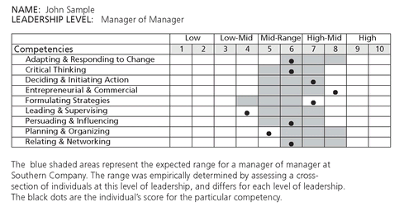

SUCCESSION PLANNING
Another recommendation made by the Leadership Action council was to expand the succession planning process to focus on identifying and planning the development of people who can take on expanded leadership roles in the future. Succession planning is done annually and consists of three major steps shown in Figure 13.3.
Identification of Potential Successors and High-Potential Individuals
In this step management identifies candidates who are ready now to fill a critical leadership position should it become vacant and candidates who, with additional development, could fill the position. Plans for all executive and director-level positions are developed. Potential successors are classified as:
• Ready Now: An individual who could be placed in the position today, without hesitation. There should be a close match between the requirements of the job and the individual’s skills, knowledge, and experience
• 1-2: An individual who needs additional development in a current position or one additional move to become ready
• Long Term: An individual in the pipeline for the targeted position and needs two to three additional moves to become ready
Management judgment, along with the assessment information described earlier, is used to identify potential successors. The identification process is generally bottom-up. A leader in a key role suggests potential successors for his or her position. This list is validated or modified as it is discussed by senior management.
A new tool, called a success profile, was developed to help managers identify the right successors. The success profile specifies the key competencies and experiences required to perform a specific leadership role. Success profiles are created by either interviewing the job incumbents and the direct manager or by sending them an Internet-based survey. The results from the interview or survey are combined and validated by executive management. Requirements are based on future business needs, not just today’s world. Specifically, a success profile identifies:
• The leadership competencies most critical for the position;
• Additional business/technical knowledge, skills, and abilities needed for the job; and
• Key experiences that best prepare someone for the position.
FIGURE 13.3.Succession Planning Process
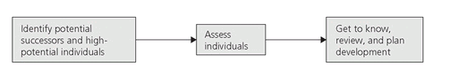
See Figure 13.4 for a sample success profile. Success profiles provide specific criteria for managers to use in selecting successors and identifying readiness. Several examples have been noted whereby the list of successors for a particular job changed as a result of using the success profile. To date, success profiles have been completed for some executive positions, and plans are to complete them for all executive and director-level jobs.
FIGURE 13.4.Sample Success Profile
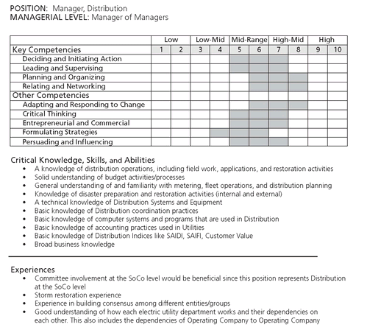
In addition to successors, management identifies high-potential individuals during the succession process. This is also done using a bottom-up approach. Managers identify individuals within their organization whom they judge to have the potential to take on expanded roles. This list is validated or modified as it is reviewed by managers up the chain.
“Potential” addresses the aptitude to perform work at the next leadership level. Managers rate the promotability of all leaders at the manager-of-manager level and above using the following categories:
• Promotable: able to make the turn to the next leadership level within two or three years. These individuals are high-potential.
• Growth: able to do additional work, run other functions, or manage a broader organization at the same leadership level.
• Well placed: having neither turn nor growth promotability.
The performance standards are the basis for making the judgment on promotability.
Below the manager-of-manager level, leaders list their high-potential individuals, rather than rating the promotability of everyone in their organizations. This is done due to large numbers. The following definition is used to assist managers in identifying high-potential individuals:
• Sustained high performance. High-potential individuals have demonstrated sustained high performance over time.
• Foundation skills. High-potential individuals possess a set of skills that allows them to grow quickly and adapt to different situations. These include drive/ ambition, strong interpersonal skills, presence, ability to learn and apply new skills quickly, strong political/organizational skills, ability to adapt to change, and resilience.
• Ability to perform future leadership roles. High-potential individuals demonstrate the aptitude to perform the performance standards at the next level of leadership.
Assessment of the Talent
In this step, successors and high-potential individuals are assessed by the external industrial psychology firm using the process previously discussed. All successors and high-potential individuals are not assessed in a single year

